

JANICE BURNS & JON DORAN
(FESTIVE TOUR BIO)

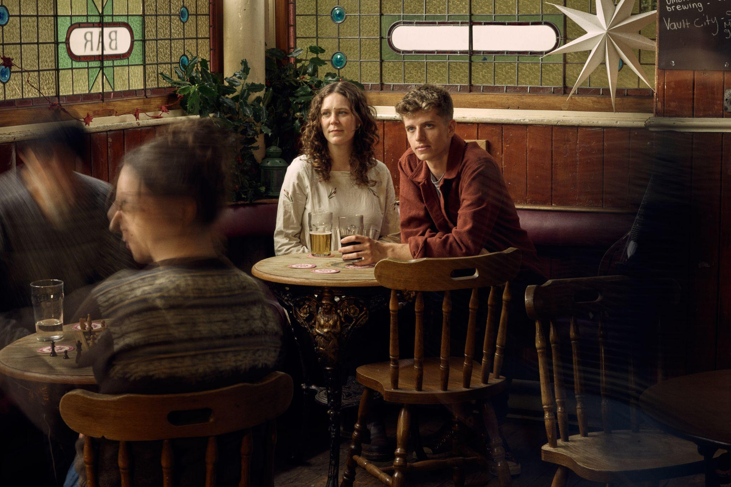

Janice Burns & Jon Doran are an award-winning Scottish and English duo who came together after discovering a shared love of traditional music. Their songs tell vivid stories about the nature of life and our place in the world.

Burns and Doran’s ‘clever and uncluttered musical storytelling’ (Songlines****) comes alive through close vocal harmonies and sensitive interplay between mandolin, bouzouki and guitar. Their arrangements have a spellbinding presence and an understated energy that transports songs from the pages of books and manuscripts into the imagination of the listener.

With their relaxed and personable approach to performance, Burns and Doran are renowned for the warmth of their connection with audiences. From Stage 2 at Cambridge Folk Festival, to Celtic Connections, Edinburgh Tradfest and Cecil Sharp House, the duo are highly sought after across the UK and beyond. They’ve performed in top venues across Europe, including Tivoli Vredenburg (Utrecht), Le Trianon (Paris), and Islington Assembly Hall (London) whilst on a support tour with pagan folk outfit, FAUN. In January 2026, they were invited to perform their songs with the BBC Scottish Symphony Orchestra at Glasgow Royal Concert Hall, with arrangements written by Pippa Murphy as part of a Celtic Connections concert celebrating the best of Scottish song.

The duo’s second studio album, Great Joy to the New, is a culmination of the years they’ve known each other and their own yearly tradition of exploring folk songs centered around the theme of winter. One of the biggest rewards of this album was collaborating with Jon Boden to write arrangements for a 5-piece brass band. The album still showcases the quiet, intimate moments that Burns & Doran are known for, with the occasional moments of delight or sentimentality that a brass band can bring.

"Burns and Doran’s 2024 collection brings mandolins, harmoniums and brass to this cosily firelit set…Head home, tune in and warm up." - The Guardian

The duo's winter gigs have become something of a tradition over the last few years, and they’re heading out to perform the songs from Great Joy to the New one last time before a well-deserved break.

People have always forged customs to survive the winter, with rituals that bring people together and bring light to the dark nights. These rituals have often been born of necessity. Beautiful, colourful, musical traditions, linked by the common cause of sustaining us spiritually, mentally, or financially through a harsh winter. Burns & Doran’s album and live show explore these themes through a collection of traditional folk songs about Christmas, winter, and optimism for the new year.

"For those yet to experience the Janice and Jon Christmas treat, Great Joy to the New is just the encouragement needed to get them out to enjoy the live experience." - KLOF

Great Joy to the New Reviews

"Burns and Doran showcase everything that makes folk so compelling: warmth, storytelling, nostalgia […] Conjures up the kind of shimmery winter days and firelit nights that any good Christmas album should deliver." - Kate Relton, Narc Magazine

"Those exquisite vocal arrangements excite and amaze as much as any of Jon and Janice’s previous work, and the brass arrangements pack such a punch that they put a smile on my face every time […] For those yet to experience the Janice and Jon Christmas treat, Great Joy to the New is just the encouragement needed to get them out to enjoy the live experience." - Johnny Whalley, KLOF

"A selection of some of the most beautiful, melodically and lyrically, Christmas and winter songs […] They describe their album as 'a celebration of winter ritual and custom to warm the heart and drive away the cold'. It is; it does." - SONGLINES ****

"A north-east England-based duo that have taken time over the last seven Decembers to exchange festive songs, Burns and Doran’s 2024 collection brings mandolins, harmoniums and brass to this cosily firelit set. Especially comforting are their takes on Down in Yon Forest (dating back to a 15th-century Derbyshire ballad), the nativity-referencing Dunstan Lullaby, and Norwegian yule song Haugebonden. Head home, tune in and warm up." - Jude Rogers, The Guardian

QUOTES

**** “Clever and uncluttered musical storytelling” – Songlines Magazine

***** “Five stars for this duo that have made an album destined for repeated listening.” – Irish Music Magazine

“They’re a revelation – crystal clear voices, great musicianship and an obvious deep love of the tradition.” – Mike Harding

“Really nicely done” – Mark Radcliffe, BBC Radio 2 Folk Show

“They play lovely strings, they have gorgeous harmony arrangements. Really well crafted,
intimate, beautifully understated.” – Karine Polwart

janandjon.com
facebook.com/janandjon
tiktok.com/@janice.jon
instagram.com/janandjonmusic
youtube.com/@janiceandjon7003

